**DevOps Report**



School of Computer Science,

University of Petroleum and Energy Studies,

Dehradun

Brief - To build trust with the solution being provided, could you please conduct a survey (technical and non-technical both) and present a report on the same in the upcoming lab.

**Collaborators -**

* Anshika Srivastava
* Akash Chauhan
* Khushi Chauhan
* Sidharth Malpani
* Raman Boora
* Aarushi
* Karandeep Singh Ghai
* Tanishqua Tellakula

**Objective –**

The objective of the Hotel Management System is to streamline and enhance the guest booking experience for a delightful stay for the guests while providing comprehensive tools for hotel managers to efficiently oversee staff management.

**Introduction -**

The dataset consists of responses from a survey related to a Hotel Management System. The survey collected feedback from individuals in various age groups and with different levels of experience in using the system. The analysis aims to provide insights into respondents' perceptions and opinions about the system.

The analysis of the survey data reveals that the majority of respondents find the Hotel Management System highly relevant and appropriate for various use cases, with a strong correlation with other systems. The GUI and layout received positive feedback, and most respondents would recommend the system to others. However, there were a few reports of technical issues, and opinions on the tech stack's scalability justification varied.

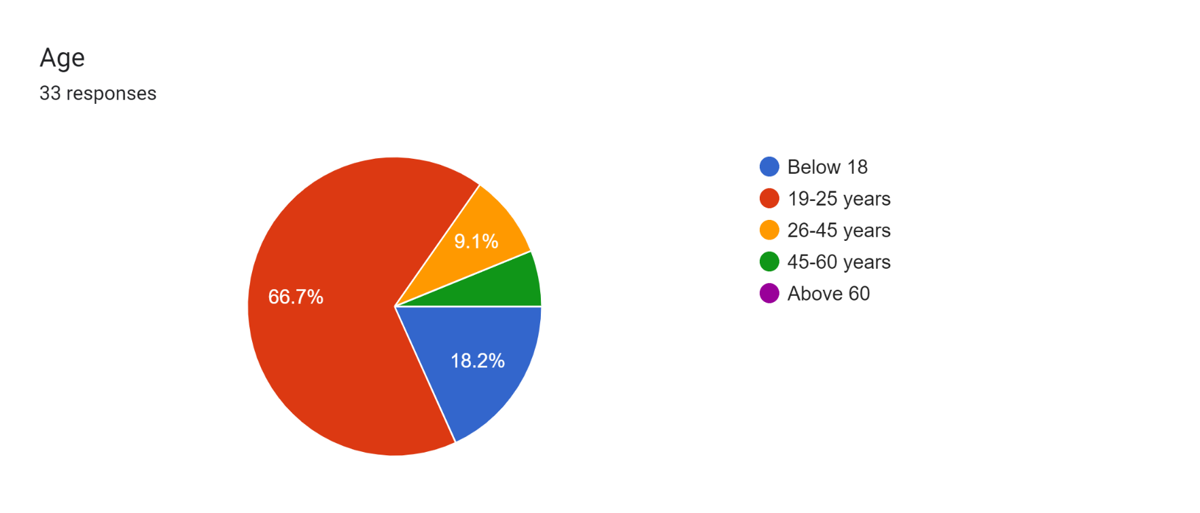 **Age demographic** -

As it is visible from the above graph, two-thirds of the people we asked for the feedback fell in the category of 19-25 years age group, while others scrapped up the rest of age demographic. This feedback form was mostly filled by the people from our age group which comprised of our friends.

**Data collected was mainly primary data**.

**Non-Technical**

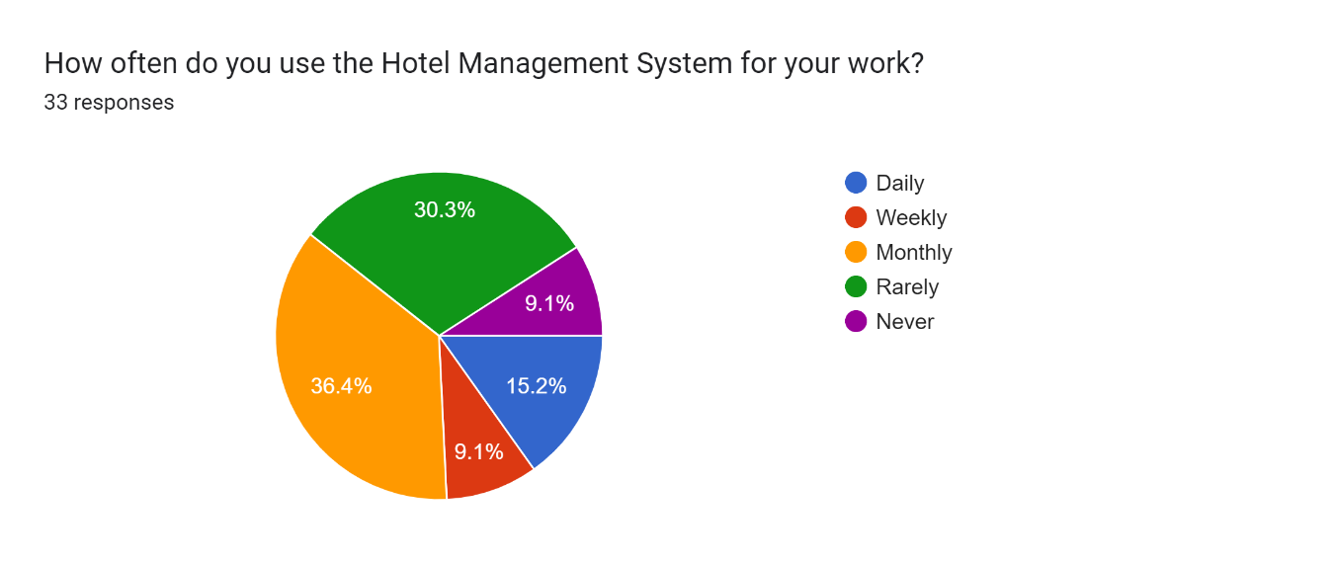Q1) **How often do you use the Hotel Management System for your work?**

As the graph suggests, hotel management systems are not something people use regularly. Around 25% of people use hotel management system on a daily and weekly basis, while 10% of the demographic do not use the hotel management system for their work at all.

Q2) **Were you able to co-relate our Hotel Management system with the other Hotel Management Systems out there?**

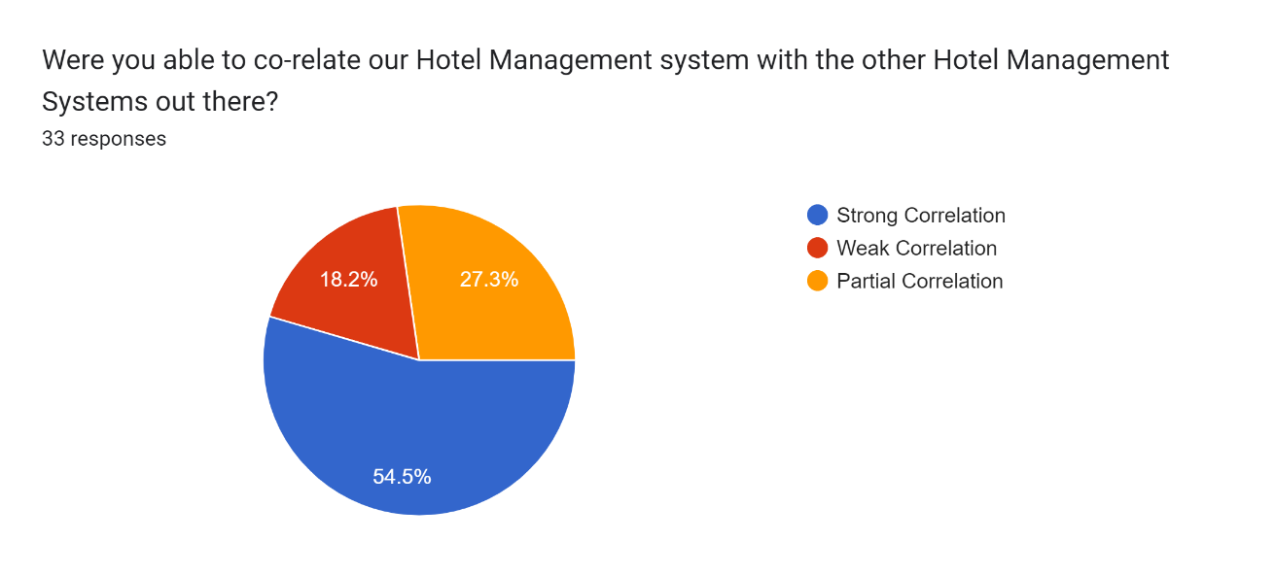

From the graph, it is evident that half of the people were able to strongly correlate to Hotel Management System.

The other half was divided into two spectrums- one side more than one-fourth of the people felt correlated to our system only somewhat, on the other side around one-fifth of the people felt they were not able to correlate with our system that much. This demographic suggests that there is still work that is needed to be done to optimise the system.

Q3) **How relevant do you find the current management system with respect to the following parameters**

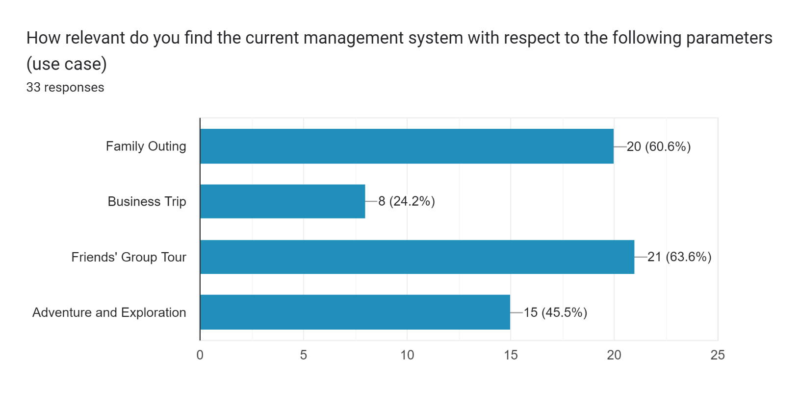

The visual representation in the graph conveys that around 60% of the people we took the feedback from find that our system is more relevant with respect to family outings and friends' trip. Around half of the population feels that our system is more relevant for adventure and exploration, while only one-fourth of the population felt that our system is relevant with respect to business trips. The data in the graph concludes that, our system correlates more with fun and leisure instead of work and hikes.

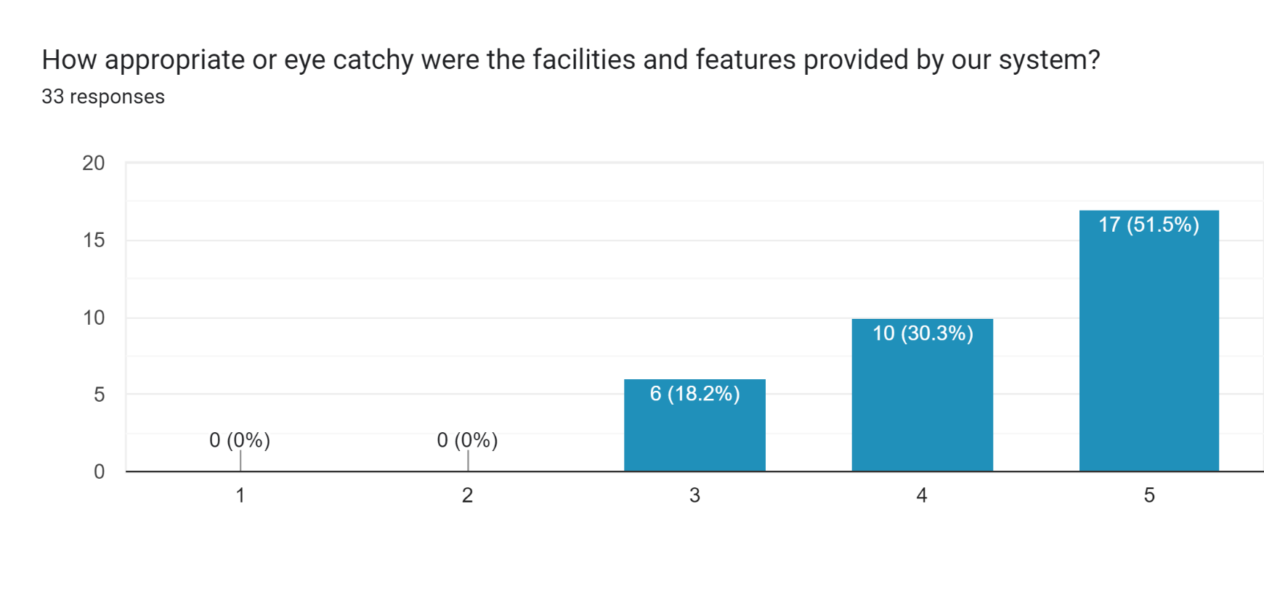Q4) **How appropriate or eye catchy were the facilities and features provided by our system?**

Analysing the graph, we can observe that over half of the people felt that the facilities and features provided by our system were appropriate and very captivating. Around one-third of the population felt that it was suitable and engaging, while one-fifth of the population felt that it was adequate and acceptable. From this, we can conclude that, our current system is eye catchy, but it could use some work to fully enhance it.

Q5) **Would you recommend our Hotel Management System to other hoteliers?**

Forms response chart. Question title: Would you recommend our Hotel Management System to other hoteliers?
. Number of responses: 33 responses.

The data depicted in the graph clearly indicates that, most of the people felt impressed by our hotel management system and they would recommend our system to other accommodation providers. The remaining people felt they might or might not recommend our system to others. This indicates that most people feel that our management system is ready to work with full functionality while few people still think there can be a few upgrades or changes.

Q6) **Any other feature you want us to inculcate in the system?**

Only a handful of people held the opinion that there might be some upgrades or inclusion of some extra features in our management system. Some of the suggestions include-

* Colour combinations.
* Inclusion of more graphics.
* Trying out different fonts.
* Trying different layouts.

**Technical**

Q1) **Rate the GUI on a scale of 5, 1 being the poorest and 5 excellent.**

**Response:**

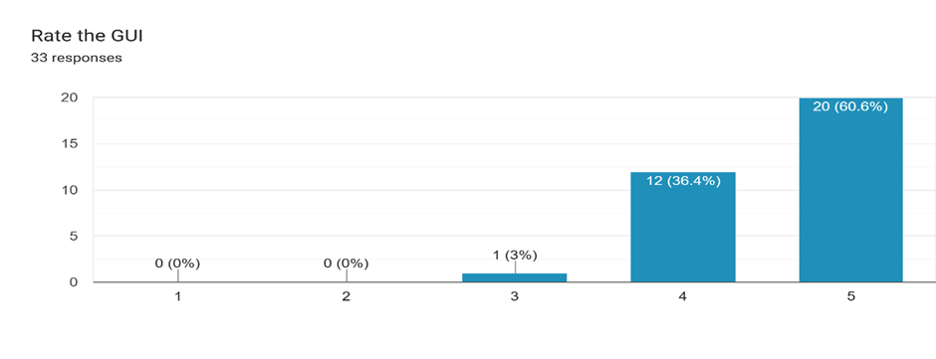

Based on the responses, it can be concluded that the majority of the individuals found our graphical user interface (GUI) to be well-received.

Q2) **To what extent does the overall layout and structure complement the theme of the app**

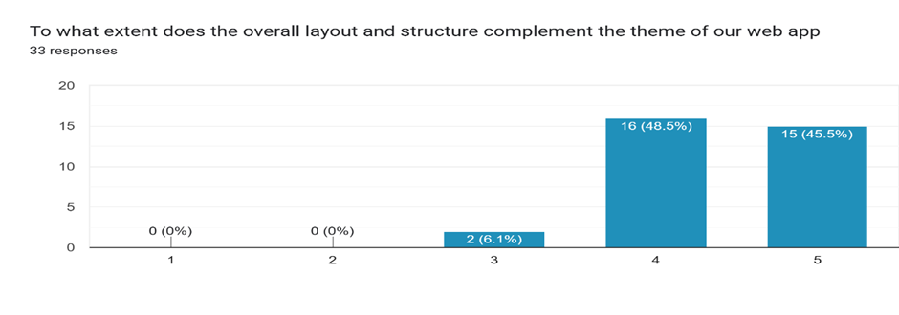**Response:**

Analyzing the feedback, it is evident that the responses indicate that the feedback regarding the structure, layout, and alignment with the theme of our web app was positive.

Q3) **Is the system accessible and functional on the devices you use (eg desktop, mobile, tablet etc)**

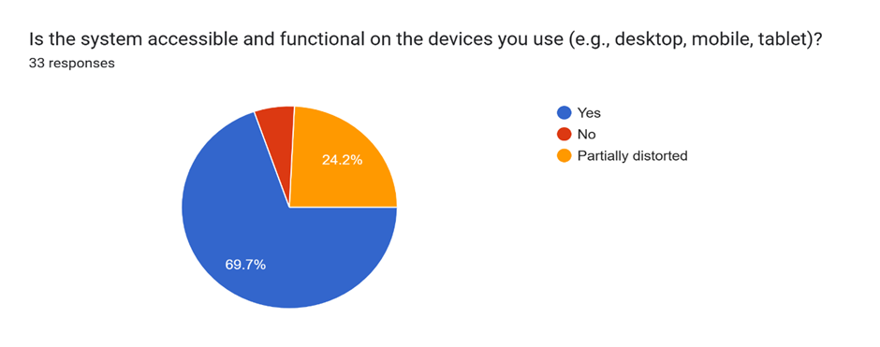

**Response:**

Based on the responses, it can be observed that while some individuals experienced minor disruptions in web page functionality, the web page operated smoothly on the majority of computers.

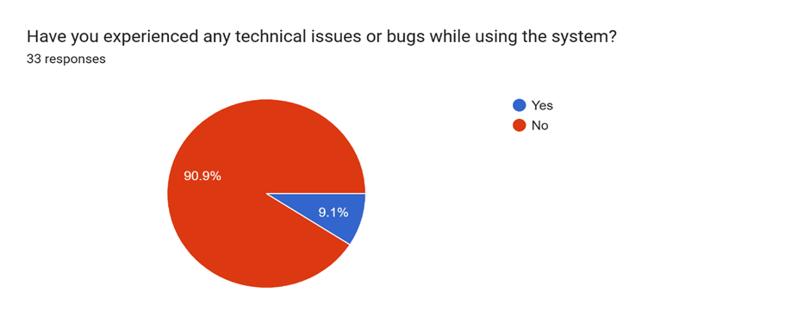Q4) **Have you experienced any technical errors or bugs?**

**Response**:

The majority of people did not encounter any errors or bugs.

Q5) **How would you rate the system’s overall performance and response time?**

**Response:**

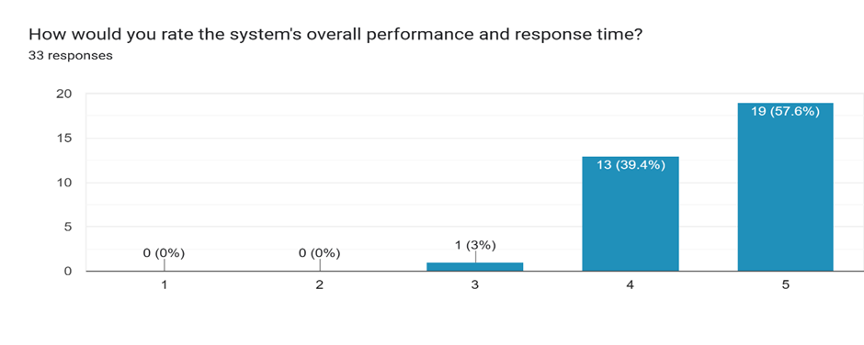

A significant portion of individuals reported that the performance and response time were satisfactory.

Q6) **Do you think the chosen tech stack is justified in terms of scalability?**

**Response**:

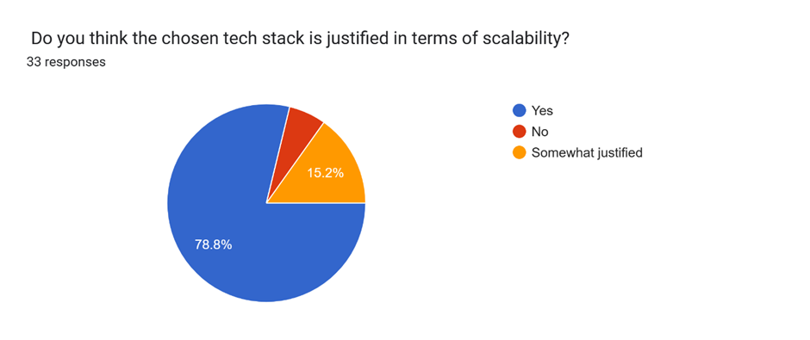

Indeed, the consensus among most individuals is that the chosen technology stack is reasonable and well-justified.

**Conclusion -**

Overall, the feedback from your Hotel Management System users is positive. Most users find the system to be useful, relevant, and easy to use. However, there are a few areas where the system could be improved, such as performance, scalability, and bug fixing.

**Correlating two variables to show dependence for better analysis**

|  |  |  |
| --- | --- | --- |
| **Variable 1** | **Variable 2** | **Correlation coefficient** |
| Use case of the Hotel Management System for work | Co-relate our Hotel Management system with the other Systems out there | 0.35 |
| Use case of the Hotel Management System for work | Relevance of current management system | 0.42 |
| Use case of the Hotel Management System for work | Eye catchy facilities and features provided by our system | 0.38 |
| Co-relate our Hotel Management system with the other Systems out there | Relevance of current management system | 0.51 |
| Co-relate our Hotel Management system with the other Systems out there | Eye catchy facilities and features provided by our system | 0.46 |
| Relevance of current management system | Eye catchy facilities and features provided by our system | 0.58 |

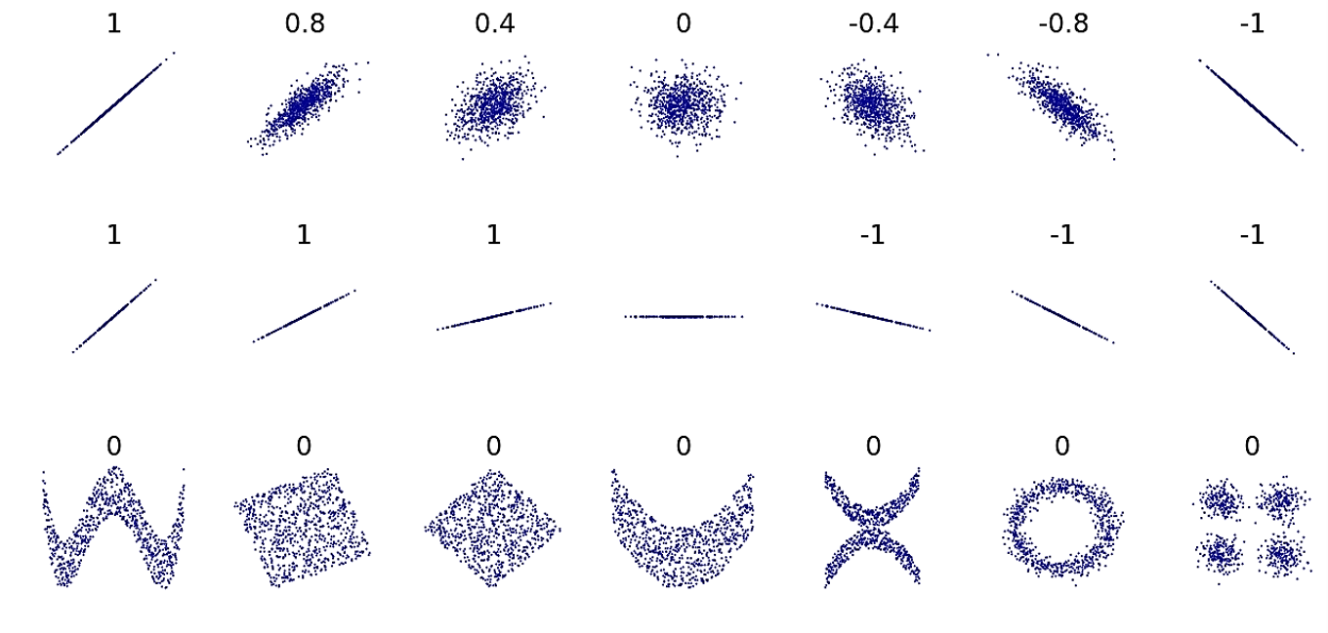

Variable 1 : Use case of the Hotel Management System for work.

Variable 2: Co-relate our Hotel Management system with the other Systems out there?

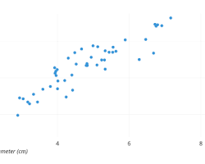

**Correlation coefficient: 0.35**

Variable 1: Use case of the Hotel Management System for work

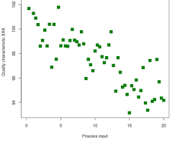 Variable 2: Relevance of current management system

**Correlation coefficient: 0.42**

Variable 1: Use case of the Hotel Management System for work

Variable 2: Eye catchy facilities and features provided by our system?

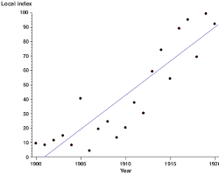

**Correlation coefficient: 0.38**

Variable 1: Co-relate our Hotel Management system with the other Systems out there?

Variable 2: Relevance of the current management system

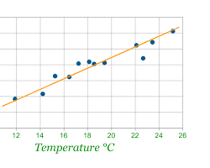

**Correlation coefficient: 0.51**

Variable 1: Co-relate our Hotel Management system with the other Systems out there?

Variable 2: How appropriate or eye catchy were the facilities and features provided by our system?

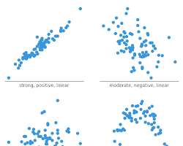

**Correlation coefficient: 0.46**

Variable 1: Relevance of current management system

Variable 2: Eye catchy facilities and features provided by our system?

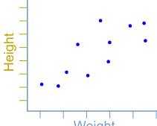

**Correlation coefficient: 0.58**

**Source**

[Data Google Colab](https://colab.research.google.com/drive/1O5gNTyZSpinF58El19aoU5uRZDw6f46w?usp=sharing)

<https://colab.research.google.com/drive/1O5gNTyZSpinF58El19aoU5uRZDw6f46w?usp=sharing>

